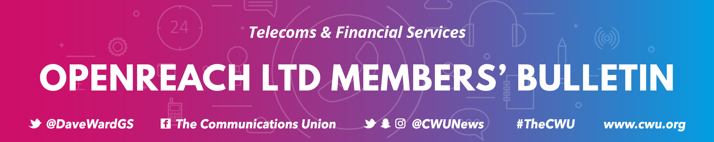

Issue No. 55/2020 | 8th April 2020

TO ALL CWU MEMBERS IN OPENREACH LTD

Dear Colleague

Openreach and Covid 19
Since the outbreak of Covid 19 the CWU has been doing all it can, both nationally and locally, to ensure that you are kept as safe as possible during this public health emergency. Things are developing very quickly.
Social Distancing and Hygiene Rules
Social distancing in line with Government, Public Health England and the HSE guidelines is not optional. In addition, the Welsh Government has now set out additional definitions relating to how this should be applied in the workplace, these include;
- Minimising the level of interaction
- Physical barriers
- Improved hygiene and reminders about the importance of hygiene.
- Washing hands well for 20 seconds with soap after close contact.
- Ensuring those with symptoms are not present on the premises.
As a result of the above changes Openreach has now issued further guidance setting out how social distancing should apply, what additional processes have been put in place and clear instructions relating to individual risk assessments. Some longer duration works, such as re-shelling of a damaged cabinet, will require additional supervision to aid the consistent application of hygiene standards. The CWU will be discussing with the company how this additional supervision will be applied.

Field members in FND, Northern Ireland and the Chief Engineers organisation (excluding civils) will receive contact from their line manager and be asked to confirm receipt of the new guidelines. Further discussions with Service Delivery and the Civils organisation are planned and further bulletins will be issued.
All these rules apply equally to Openreach’s 3rd party suppliers and any breaches of the appropriate protocols must be reported to Openreach and your local CWU Branch immediately in order to ensure your safety and that of others.
The CWU’s position remains clear that if following an individual risk assessment either prior to or during any work taking place you believe social distancing or hygiene rules cannot be applied then you must;
- Immediately stop work
- Make the site safe
- Inform your manager
The CWU will always support you in putting your safety first and will not tolerate pressure being placed on any member to continue working in these circumstances. If the appropriate hygiene materials are not available do not proceed.

Contact the CWU
The Union remains here to keep you safe and assist you through this difficult time. If you have any concerns or need assistance please contact your local rep or Branch. If you don’t know which Branch you are in you can find out via www.cwu.org/contact-us.

