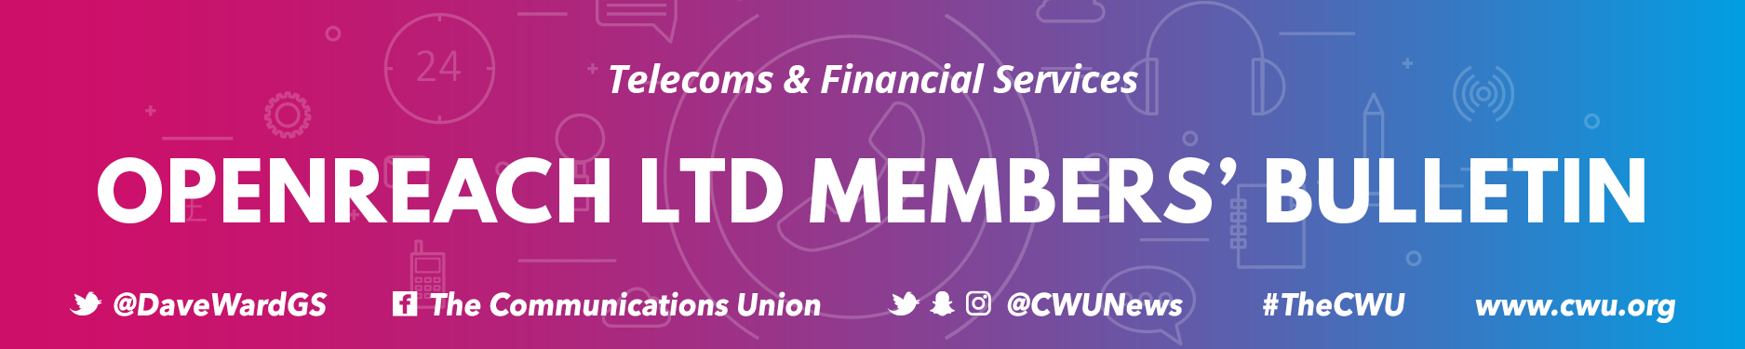

Issue No. 57/2020 | 9th April 2020

TO ALL CWU MEMBERS IN OPENREACH SERVICE DELIVERY

Dear Colleague

Service Delivery Engineers and Covid 19
Since the outbreak of Covid 19 the CWU has been doing all it can, both nationally and locally, to ensure that you are kept as safe as possible during this public health emergency. Things are developing very quickly. We took the decision to produce this specific communications for members in Service Delivery as we are aware of the unique challenges you have within your role.
Entering Premises
Openreach has issued revised working practices for both provision and repair tasks. If you are on a Provision task you must not enter the customer’s premises, except in specific exceptional circumstances.
The new guidelines are being sent to everyone, are designed to ensure your safety is paramount in all cases, and must be followed rigidly.
If at any time, as a result of your personal risk assessment, you feel unsafe you must:

- Immediately stop work; make the site safe; inform your manager

On Repair tasks, prove service is working to the last accessible external point. If access is still required, and the task is non-appointed, further the task back to the CP.
If access is required on an appointed task, you must follow the strict guidelines and ‘questions to be asked’. Only enter if it is absolutely necessary and ensure all safety precautions are taken. We cannot over-emphasise that, if you have completed a personal risk assessment and you feel unsafe, you must:

- Immediately stop work; make the site safe; inform your manager

Please ensure that the correct processes are followed in these situations. This is for your safety and others around you.

Social Distancing
In regards to social distancing, 2 metres absolutely must be adhered too. If you have a specific job and, especially in network solutions, if a task cannot be achieved without coming within 2m, but not physically touching, you must conduct a thorough risk assessment. Figure out a work around, use the ‘step out and step in’ method and come up with engineering ideas that provide safe solutions. If, and only if, this is not possible, then you must ensure the risk assessment has been completed and you come together for as short as period as possible. There are specific safe working guidance in these exceptional circumstances which must be strictly followed.

Vehicle Sharing
Do not share vehicles at any time, including during breaks. Please use wipes to sanitise and clean any areas that you meet within your vehicle, especially van keys, fuel card, door handles, vehicle controls. Remember to dispose of any wipes correctly. The company should be supplying you with the appropriate PPE; like gloves and wipes/hand wash/hand sanitiser. We know there is a national shortage but patch managers can purchase these locally. Do NOT use another vehicle unless you are certain the previous engineer is not off due to COVID-19.

If an Openreach engineer becomes a suspected COVID-19 case the advice from Public Health England and BT is to secure the van for 72 hours. Openreach has agreed to extend this period of quarantine to 96 hours as an additional precaution. Before the next use, the new driver must use anti-bacterial wipes to clean frequently contacted areas (e.g. steering wheel, door handles etc), the dashboard area and hard surfaces as part of normal good hygiene practice.

The CWU’s position remains clear that if, following an individual risk assessment either prior to or during any work taking place, you believe social distancing or hygiene rules cannot be applied then you must:

- Immediately stop work
- Make the site safe
- Inform your manager

The CWU will always support you in putting your safety first and will not tolerate pressure being placed on any member to continue working in these circumstances. If the appropriate hygiene materials are not available do not proceed.

Contact the CWU
The Union remains here to keep you safe and assist you through this difficult time. If you have concerns or need assistance please contact your local rep or Branch. If you don’t know which Branch you are in you can find out via www.cwu.org/contact-us.

We are here to help. Keep Safe
From Davie Bowman
Assistant Secretary

