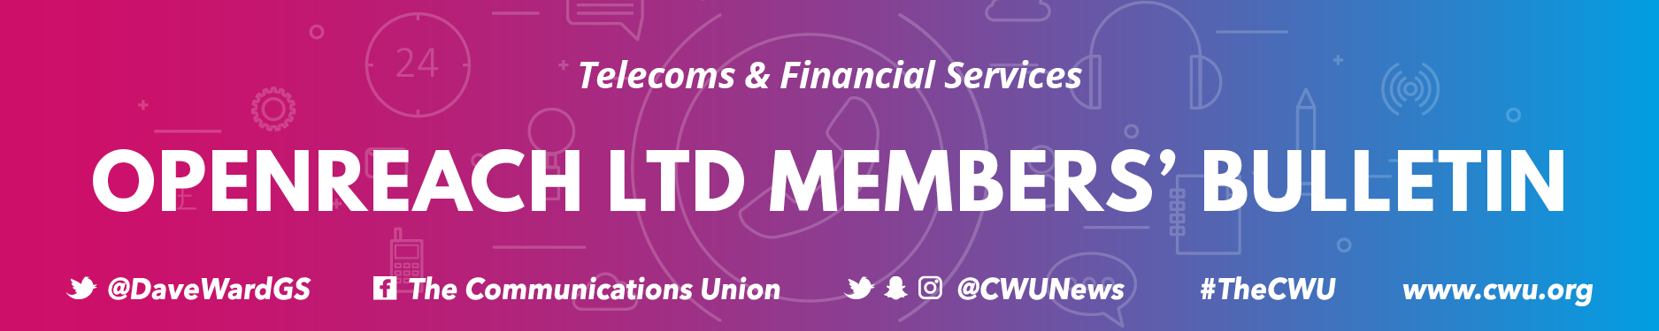

Issue No. 59/2020 | 9th April 2020

TO ALL CWU MEMBERS IN OPENREACH REPAYMENT PLANNING

Dear Colleague

Repayment Planners and Covid 19
Since the outbreak of Covid 19 the CWU has been doing all it can, both nationally and locally, to ensure that you are kept as safe as possible during this public health emergency. Yesterday (Wednesday) a bulletin outlining the current situation across Openreach was emailed to members across the company – but we’ve now taken the decision to produce a specific communication for our Repayment Planner members as we are aware of the unique challenges you face within your role.
Following what was a change in approach by the company to the way that you work, discussions have taken place with the Senior Management team to clarify the position.
The company has told the CWU that, subsequent to those talks, additional briefings have taken place covering the issues highlighted by the union.

Key safety messaging and guidelines secured by the CWU (in the company’s own words) are:

- Understanding that safety is paramount and of the utmost importance
- Ensuring every engineer understands and observes the 360˚ / 2m rule and how to apply that on survey visits, also no sharing of vans/vehicles.
- Our engineers are clear on key worker status and will operate appropriate signage if they are conducting surveys – see https://openreach.workplace.com/groups/928486270827030/permalink/1133593733649615/
- Ensuring that surveys are undertaken in isolation unless two people are required (manhole surveys) in which case 2m separation will be observed with the ‘bottom man and top man’.
- Our RPEs will be focusing on their own workstack (surveys, planning) – if we have surplus capacity we may look at future ability to support “build” and ‘clerk of works’ type activity, again our engineers work in field and at home for planning/admin type activity.
- We will be operating a model where those people outside doing surveys pass work electronically back to people who are self-isolating or vulnerable and unable to leave home.
- We will ensure RPEs are clear that once surveys are conducted, they return to home and not their normal office building, we are also suggesting surveys are completed early morning when minimal people are out and about.

To reinforce those messages, and in addition to the above, the advice from the CWU is:

- Do not share vehicles at any time, including during breaks. Please use wipes to sanitise and clean any areas that you meet within your vehicle, especially van keys, fuel card, door handles, vehicle controls. Remember to dispose of any wipes correctly. The company should be supplying you with the appropriate PPE; like gloves and wipes/hand wash/hand sanitiser, we know there is a national shortage but patch managers can purchase these locally. Do NOT use another van unless you are certain the previous engineer is not off due to COVID-19.

- If an Openreach engineer becomes a suspected COVID-19 case: The advice from Public Health England and BT is to secure the van for 72 hours. Openreach, however, has agreed to extend this period of quarantine to 96 hours as an additional precaution. Before the next use, the new driver must use anti-bacterial wipes to clean frequently contacted areas (e.g. steering wheel, door handles etc), dashboard area and other hard surfaces as part of normal good hygiene practice.

The CWU’s position remains clear that if, following an individual risk assessment either prior to or during any work taking place, you believe social distancing or hygiene rules cannot be applied then you must:

- Immediately stop work
- Make the site safe
- Inform your manager

The CWU will always support you in putting your safety first. To be clear, the union will not tolerate pressure being placed on any member to continue working in these circumstances. If the appropriate hygiene materials are not available do not proceed.

Contact the CWU
The Union remains here to keep you safe and assist you through this difficult time. If you have concerns or need assistance please contact your local rep or Branch. If you don’t know which Branch you are in you can find out via www.cwu.org/contact-us.

We are here to help. Keep Safe

From Davie Bowman
Assistant Secretary

